Task on IAM:

*Create one IAM user and assign ec2,s3 full access role*.

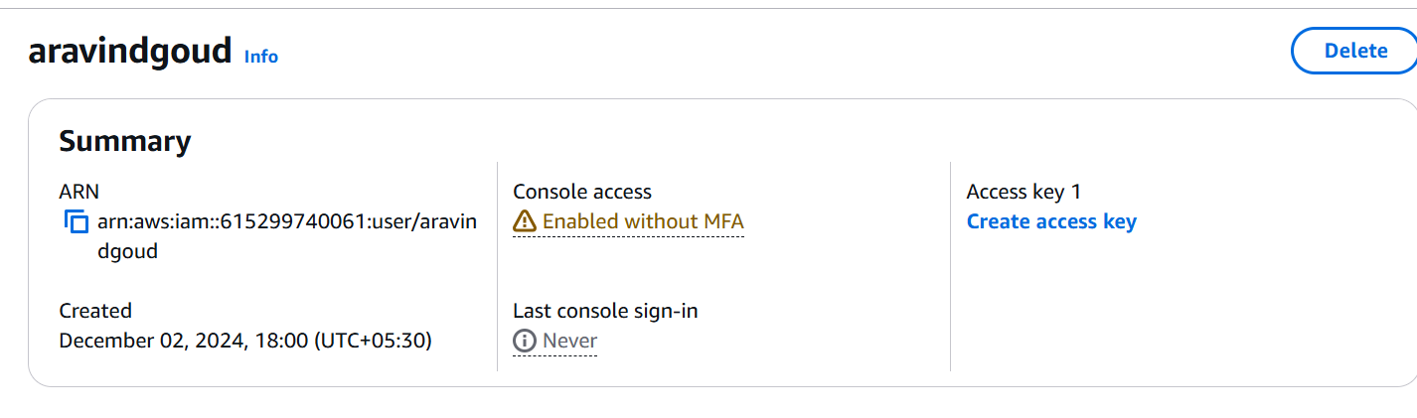

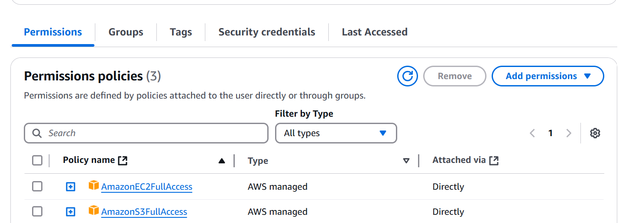

*Create one Group in IAM and Assign Read access for ec2.*

*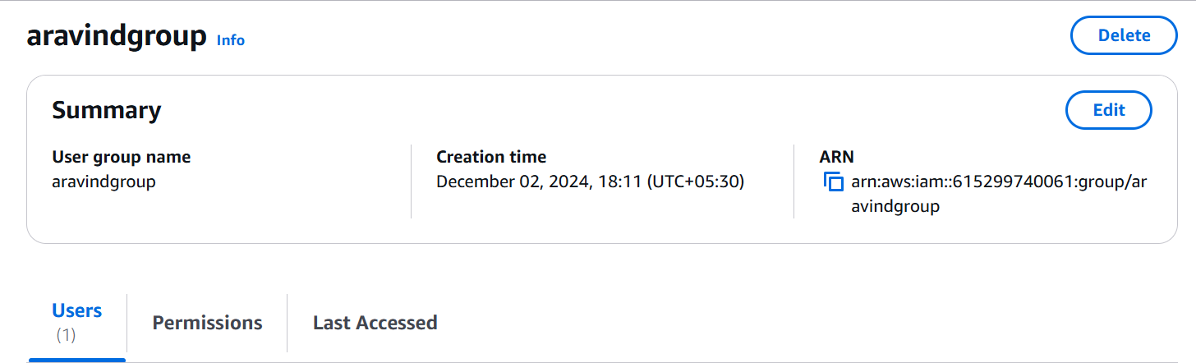*

*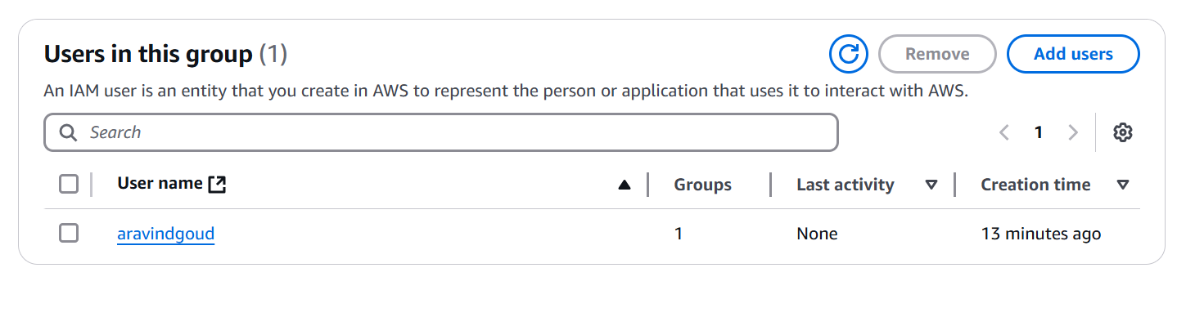*

*Create a new user with name Devops and add to the group created in task2.*

*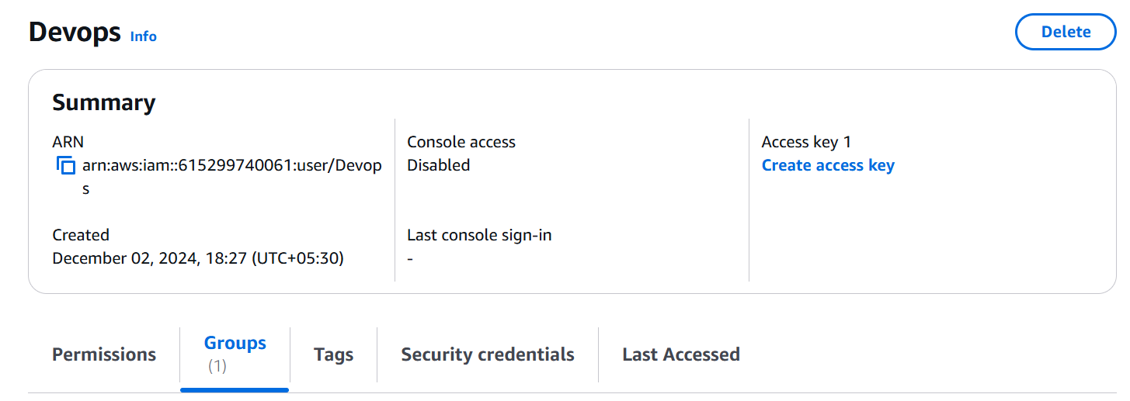*

*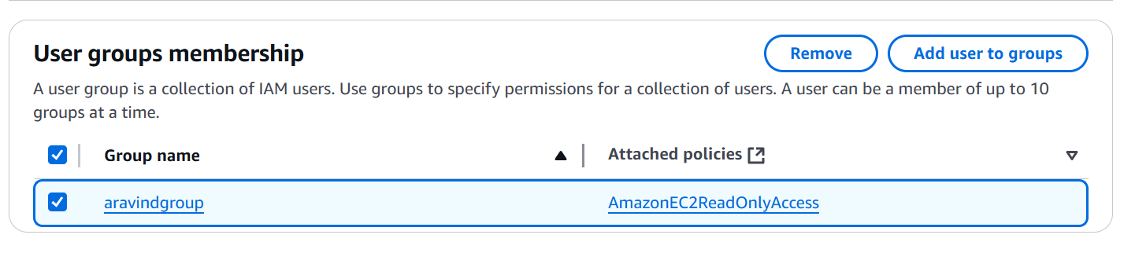*

*Create a IAM policy to access ec2 for a specific user in specific regions only.*

*